**XPATH EXAMPLES**

1. Please Navigate to Google.com and get all the XPATHS from the below image

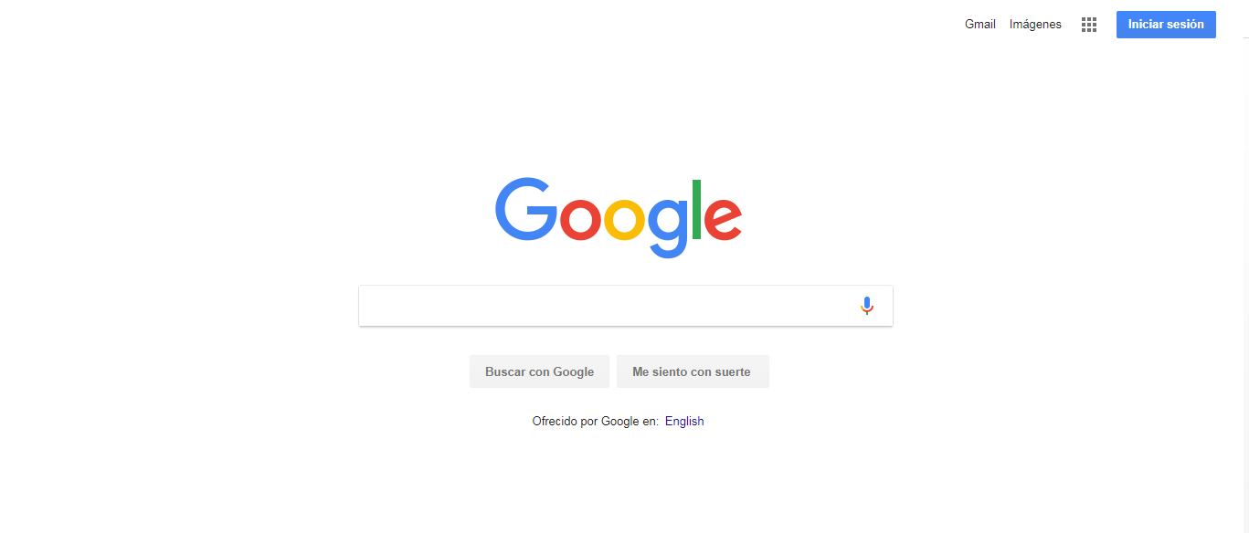

|  |  |
| --- | --- |
| **ELEMENTO** | **XPATH** |
| Gmail | (//a[text()="Gmail"])[1] |
| Log in | //a[text()="Iniciar sesión"] |
| Search | //a[@name=”q”] |
| Lucky | //input[@value="Me siento con suerte"] |

1. Go to DemoQA.com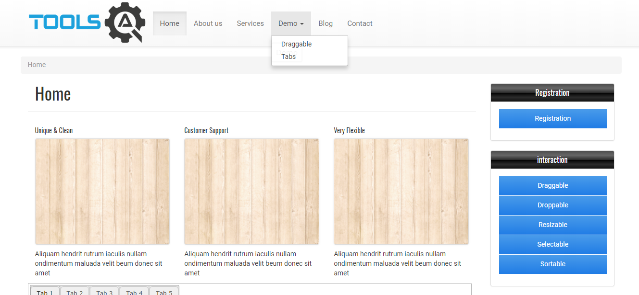

|  |  |
| --- | --- |
| **ELEMENTO** | **XPATH** |
| home | //a[@title="Home"] |
| Draggable | //a[title ="Graggable"] |
| Registration | //a[text() ="Registration"] |
| Customer Support | **Ya no está la página** |
| Selectable | //a[text() ="Selectable"] |

1. Go to Hexaware.com



|  |  |
| --- | --- |
| **ELEMENTO** | **XPATH** |
| Hexaware | //a[@href="https://hexaware.com"] |
| Service | (//a[@title="SERVICES"])[1] |
| Search | (//img[@data-target="#searchModal"])[1] |
| Menu | //div[@class="mbl-menu pull-right"] |
| I agree | //a[text() = "I agree"] |
| Close | //span[@style="float:right;cursor: pointer;"] |

1. Go to Udemy.com



|  |  |
| --- | --- |
| **ELEMENTO** | **XPATH** |
| Udemy | //a[@data-tracking-event="logo"] |
| Search | //input[@placeholder="Buscar cursos"] |
| Little car | //a[@href="/cart/"] |
| Log In | (//button[text() ="Iniciar sesión"])[1] |
| Search 2 | //input[@data-purpose="home-quick-search-box"] |

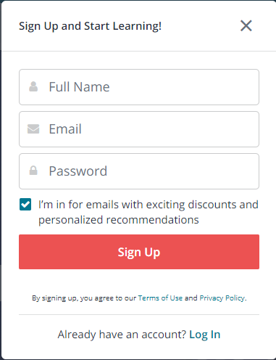

|  |  |
| --- | --- |
| **ELEMENTO** | **XPATH** |
| Udemy | //a[@data-tracking-event="logo"] |
| X | //button[@data-purpose="close-popup"] |
| Full Name | //input[@data-purpose="fullname"] |
| Checkbox | //input[@type="checkbox"] |
| Sign Up | //input[@value="Regístrate"] |
| Log In | //a[@data-purpose="login-link-signup-popup"] |